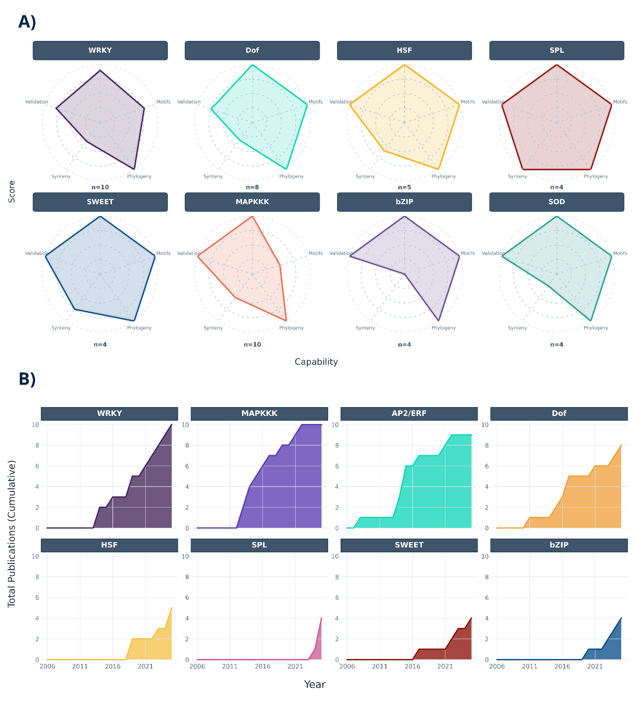
Figure 7. Gene family functional capability and evolution. (A) Radar graphs indicating the maturity of the research on the different gene families (e.g., WRKY, Dof, SPL) are measured in five dimensions: Validation, Motifs, Phylogeny, Synteny, and Score. (B) Temporal graph representing the cumulative publication trends of the family-specific research over the years.

